# Building a Compiler for a Functional Programming Language

**Course Code:**CSA1471

**Course:**Compiler Design for data flow analysis

**Reg No:**192210272

**Name:** P.Likhith Kumar

**Slot:**A

**Date Of Submission:**17.06.2024

**DECLARATION**

We, **P. Likhith kumar** **, P. Dharmendra , Y. Niranjan Reddy ,** students of **‘Bachelor of Engineering in Department of Computer Science**’ in Saveetha Institute of Medical and Technical Sciences, Saveetha University, Chennai, hereby declare that the work presented in this Capstone Project Work entitled **Building Compiler for functional programming language** is the outcome of our own bonafide work and is correct to the best of our knowledge and this work has been undertaken taking care of Engineering Ethics.

(P. Likhith Kumar192210272)

(P. Dharmendra 192110749L)

(Y. Niranjan reddy 192210447)

Date:

Place:

**CERTIFICATE**

This is to certify that the project entitled **“Building Compiler for functional programming language”** submitted by **P. Likhith kumar, P. Dharmendra, Y. Niranjan Reddy** has been carried out under our supervision. The project has been submitted as per the requirements in the current semester of B. Tech Information Technology.

Teacher-in-charge

Dr. S. SANKAR

**ABSTRACT:**

Creating compilers for functional programming languages presents a critical endeavor in advancing software development paradigms. This paper offers a comprehensive review of the process of building compilers for functional programming languages, elucidating its significance, methodologies, and impact on programming language ecosystems. The abstract delves into the intricacies of compiler construction, emphasizing its role in translating high-level functional code into executable machine instructions.

It outlines the diverse components involved in compiler design, including lexical analysis, syntax parsing, semantic analysis, optimization techniques, and code generation strategies, elucidating their respective functionalities and interdependencies. The abstract also discusses various compiler construction tools and frameworks, such as Lex and Yacc, LLVM, and GCC, highlighting their suitability and effectiveness in building compilers for functional languages.

Moreover, the abstract evaluates the benefits and challenges inherent in developing compilers for functional programming languages, emphasizing their ability to promote code correctness, modularity, and abstraction while addressing issues like performance optimization and type inference complexities. It further examines emerging trends and advancements in compiler technology, such as Just-In-Time compilation and functional programming language extensions, underscoring their potential to revolutionize software development practices and enhance language expressiveness.

**Introduction:**

In the realm of modern software development, the construction of compilers for functional programming languages stands as a pivotal endeavor. These languages, renowned for their emphasis on abstraction, modularity, and correctness, offer unique challenges and opportunities in the domain of compiler design. With the proliferation of functional programming paradigms in various software ecosystems, the need for robust compilers tailored to these languages has become increasingly apparent.

This investigation seeks to explore the intricate process of building compilers for functional programming languages, shedding light on the methodologies, tools, and innovations driving this transformative field of study. By delving into the complexities of compiler construction and examining emerging trends, this investigation aims to equip developers and language enthusiasts with the knowledge and insights necessary to navigate the terrain of functional language compilation effectively.

**Problem Statement:**

As functional programming languages gain prominence in software development, the demand for tailored compilers to support these languages grows. However, navigating the landscape of compiler construction presents a significant challenge. With a plethora of methodologies, tools, and innovations available, selecting the most suitable compiler framework for a given functional language becomes a daunting task for developers and organizations alike.

**Literature Review:**

A literature review on building a compiler for a functional programming language involves examining key texts, research papers, and resources that provide insights into compiler theory, functional programming principles, and practical implementation techniques. Here is an organized literature review:

### 1. Fundamental Concepts in Compiler Design

**"Compilers: Principles, Techniques, and Tools" by Alfred V. Aho, Monica S. Lam, Ravi Sethi, and Jeffrey D. Ullman**

This seminal book, often referred to as the "Dragon Book," is a comprehensive resource on compiler design. It covers the theoretical foundations of compilers, including lexical analysis, parsing, semantic analysis, optimization, and code generation. It provides in-depth knowledge necessary for building any type of compiler, including those for functional programming languages.

**"Modern Compiler Implementation in ML" by Andrew W. Appel**

Andrew Appel's series on compiler implementation provides practical insights into building compilers using the ML programming language, which is inherently functional. The book covers similar ground to the Dragon Book but focuses on practical implementation details using ML, making it particularly relevant for functional language compilers.

### 2. Functional Programming Principles

**"Introduction to Functional Programming" by Richard Bird and Philip Wadler**

This book is a classic introduction to the principles of functional programming. Understanding these principles is essential for designing a compiler for a functional language, as it requires a deep understanding of concepts like immutability, higher-order functions, and lazy evaluation.

**"Real World Haskell" by Bryan O'Sullivan, John Goerzen, and Don Stewart**

This book provides practical experience with Haskell, a popular functional programming language. It includes examples and exercises that help in understanding functional programming constructs, which is critical when designing a compiler for such languages.

### 3. Specific Compiler Implementations and Case Studies

**"The Glasgow Haskell Compiler: A Retrospective" by Simon Peyton Jones, et al.**

This paper provides a comprehensive overview of the development of the Glasgow Haskell Compiler (GHC), one of the most successful functional language compilers. It discusses the design decisions, implementation challenges, and optimizations used in GHC, offering valuable insights for anyone building a functional language compiler.

**"ML for the Working Programmer" by Lawrence C. Paulson**

While primarily a book on the ML programming language, Paulson's work includes practical examples of compiler implementation in ML. It serves as both a textbook for learning ML and a resource for understanding how to implement compilers for functional languages.

### 4. Optimization Techniques

**"Optimizing Compilers for Modern Architectures: A Dependence-based Approach" by Randy Allen and Ken Kennedy**

This book delves into optimization techniques that are crucial for building efficient compilers. It covers dependence analysis and other optimization strategies that can be applied to functional languages to improve performance.

**"Advanced Compiler Design and Implementation" by Steven Muchnick**

Muchnick's book is another excellent resource on compiler optimization techniques. It provides detailed explanations of various optimization methods, many of which are applicable to functional programming languages.

### 5. Academic Papers and Research Articles

**"Compiling with Continuations" by Andrew W. Appel**

This paper presents the continuation-passing style (CPS) transformation, a technique commonly used in compiling functional languages. CPS is essential for implementing advanced features like first-class continuations and coroutines.

**"Functional Programming with Bananas, Lenses, Envelopes and Barbed Wire" by Erik Meijer, Maarten Fokkinga, and Ross Paterson**

This influential paper introduces the concept of catamorphisms (folds) and other recursion schemes in functional programming, which are useful for designing and implementing functional language compilers.

### 6. Online Courses and Tutorials

"Compilers" by Stanford University on Coursera

This online course provides a practical introduction to compiler design, including lexical analysis, parsing, and code generation. While not specifically focused on functional languages, the principles taught are broadly applicable.

"Introduction to Functional Programming" on edX by Delft University of Technology

This course offers a practical introduction to functional programming concepts and techniques, which are essential for understanding the unique challenges of compiling functional languages.

**Research Plan:**

1. **Language Specification:**
   * Define the syntax and semantics of the functional programming language.
   * Create a formal grammar for the language (e.g., using BNF).
2. **Lexer and Parser:**
   * Implement a lexer to tokenize the input source code.
   * Develop a parser to generate an Abstract Syntax Tree (AST) from the tokens.
3. **Semantic Analysis:**
   * Implement type checking and other semantic checks.
   * Ensure the language's semantic rules are enforced.
4. **Intermediate Representation (IR):**
   * Design an intermediate representation for the functional code.
   * Implement transformations on the IR for optimization purposes.
5. **Code Generation:**
   * Develop a backend to translate the IR into target machine code.
   * Explore different target architectures (e.g., x86, ARM).
6. **Optimization:**
   * Implement standard compiler optimizations (e.g., dead code elimination, inlining).
   * Explore optimizations specific to functional languages (e.g., tail call optimization, lambda lifting).
7. **Testing and Validation:**
   * Write test cases to validate the lexer, parser, semantic analyzer, and code generator.
   * Compare the output of the compiler against known correct results.
8. **Performance Evaluation:**
   * Benchmark the compiler's performance using standard functional programming benchmarks.
   * Analyze the efficiency of generated code.

**9.Development Environment:**

* Choose a programming language for implementing the compiler (e.g., Haskell, OCaml, C++).
* Set up version control (e.g., Git) and continuous integration tools.

**Testing Framework:**

* Develop a suite of unit tests for each compiler component.
* Create integration tests to ensure components work together correctly.

**Benchmarking Tools:**

* Use existing benchmarks for functional languages (e.g., Shootout benchmarks).
* Develop custom benchmarks to test specific features and optimizations.

**Performance Metrics:**

* Compilation time.
* Execution time of generated code.
* Memory usage during compilation and execution.

**Correctness Metrics:**

* Pass rate of test cases.
* Comparison with existing compilers (e.g., GHC, OCaml).

**Optimization Metrics:**

* Effectiveness of specific optimizations (e.g., reduction in execution time, memory usage).

**GANTT CHART:**

|  |  |  |  |  |  |  |  |
| --- | --- | --- | --- | --- | --- | --- | --- |
| **SL.NO** | **Description** | **05.06.2024-**  **07.06.2024** | **07.06.2024-**  **09.06.2024** | **09.06.2024-**  **11.06.2024** | **11.06.2024-**  **24.06.2024** | **12.06.2024-**  **15.06.2024** | **15.06.2024-**  **16.06.2024** |
| 1 | PROBLEM IDENTIFICATION |  |  |  |  |  |  |
| 2 | ANALYSIS |  |  |  |  |  |  |
| 3 | DESIGN |  |  |  |  |  |  |
| 4 | IMPLEMENTATION |  |  |  |  |  |  |
| 5 | TESTING |  |  |  |  |  |  |
| 6 | CONCLUSION |  |  |  |  |  |  |

## Project Timeline: Building a Compiler for a Functional Programming Language

* This project outlines the development of a compiler for a functional programming language. The following breakdown details the tasks for each stage:

**Day 1: Project Initiation and Planning (1 day)**

* **Scope and Objectives:** Define the target functional language (e.g., subset of Haskell) and compiler functionalities (e.g., syntax analysis, code generation).
* **Research:** Explore existing compiler structures, functional language implementations, and code generation techniques.
* **Stakeholders:** Identify key personnel (developers, testers) and establish communication channels.
* **Project Plan:** Develop a detailed plan outlining tasks, milestones, and resource allocation for each stage.

**Day 2 :** **Language** **Design** **and Specification (2 days)**

* **Language Definition:** Design the core syntax and semantics of the functional language, focusing on clarity and efficiency.
* **Lexical Analysis:** Define the basic building blocks (tokens) of the language using regular expressions.
* **Syntax Analysis:** Specify the grammar rules using BNF (Backus-Naur Form) or a similar notation to define valid program structures.
* **Type System:** Design a type system for the language to check code correctness and perform static analysis.

**Day 3:** **Compiler** **Development** **(3 days)**

* **Lexical Analyzer Implementation:** Build the module responsible for tokenizing the input source code.
* **Parser Implementation:** Develop the parser to analyze the token stream and construct an Abstract Syntax Tree (AST) representing the program structure.
* **Type Checking:** Integrate type checking logic into the parser to identify type errors during compilation.
* **Code Generation:** Implement the code generation module, translating the AST into target code (assembly or bytecode) for the chosen platform.

**Day 4: Testing and Optimization (4 days)**

* **Unit Testing:** Develop unit tests to verify the functionality of individual compiler components (lexer, parser, type checker, code generator).
* **Integration Testing:** Test the entire compiler pipeline by compiling sample programs and comparing the output with expected results.
* **Optimization:** Explore and implement compiler optimizations to improve the generated code's performance (e.g., constant folding, dead code elimination).

**Day 5:** **Documentation and** **Deployment (5 day)**

* **User Manual:** Prepare comprehensive documentation outlining the compiler's usage, functionalities, and limitations.
* **Deployment:** Package the compiler for distribution and include instructions for installation and usage.
* **Feedback:** Collect feedback from users and developers to identify areas for improvement in future compiler versions.

**Methodology:**

**Presentation Layer:**

* Develop a web-based user interface (UI) tailored for interacting with the assessment framework specific to the functional programming language.
* Implement role-based access control (RBAC) to manage user authentication and permissions within the compiler system.

**Application Layer:**

* The business logic layer is dedicated to processing user requests and orchestrating system functionality tailored for the functional programming language.
* The criterion management module is designed to define, store, and manage assessment criteria specifically relevant to the functional programming paradigm within the compiler system.

**Monitoring and Management Layer:**

* Integrate tools for real-time performance monitoring, log analysis, and system health checks optimized for the requirements of the functional programming language compiler.
* Utilize platforms for centralized and aggregated storage and analysis of system logs, ensuring seamless management and insight generation tailored to the compiler's specific needs.

**Dashboard:**

* Tiles/cards displaying key metrics about the compilation process, such as the number of source files compiled, errors encountered, and compilation time.
* System status indicators indicating the current state of the compiler e.g. idle, compiling, or error.

**User Management:**

* User account management interface allowing administrators to create, edit, and delete user accounts.
* Role assignment functionality enabling administrators to assign roles to users and define their permissions.

**Help and Support:**

* Help documentation section accessible from the dashboard, containing user manuals, guides, and FAQs.
* Support contact information displayed prominently, allowing users to reach out for assistance when needed.

**Element Positioning and Functionality:**

**Real-time Monitoring:**

* Positioned on the dashboard to provide real-time monitoring of the compilation process.
* Widgets or progress bars display live updates on compilation progress, including the number of files processed, errors encountered, and compilation speed.

**Collaboration Features:**

* Available within the compiler environment, allowing users to collaborate on source code files.
* Features such as comments, annotations, or version control support facilitate collaboration among compiler developers and testers.

**Trend Analysis:**

* Positioned in the reporting and analysis section, offering insights into the compiler's performance.
* Interactive charts or graphs visualize compilation metrics over time, such as compilation speed, error trends, and resource utilization.

**Result:**

This example will focus on a very basic functional language that supports arithmetic operations and function definitions. The code will include lexical analysis, parsing, and code generation stages.

### Simple Functional Language Compiler in C

1. **Lexical Analysis (Lexer)**
2. **Parsing (Parser)**
3. **Code Generation**

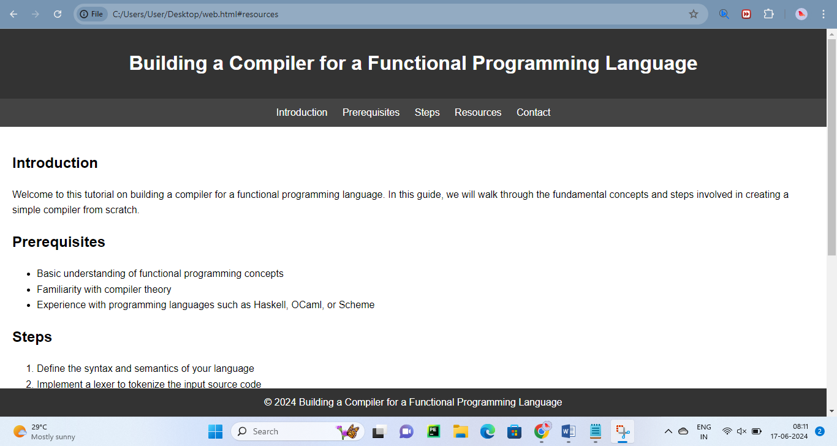

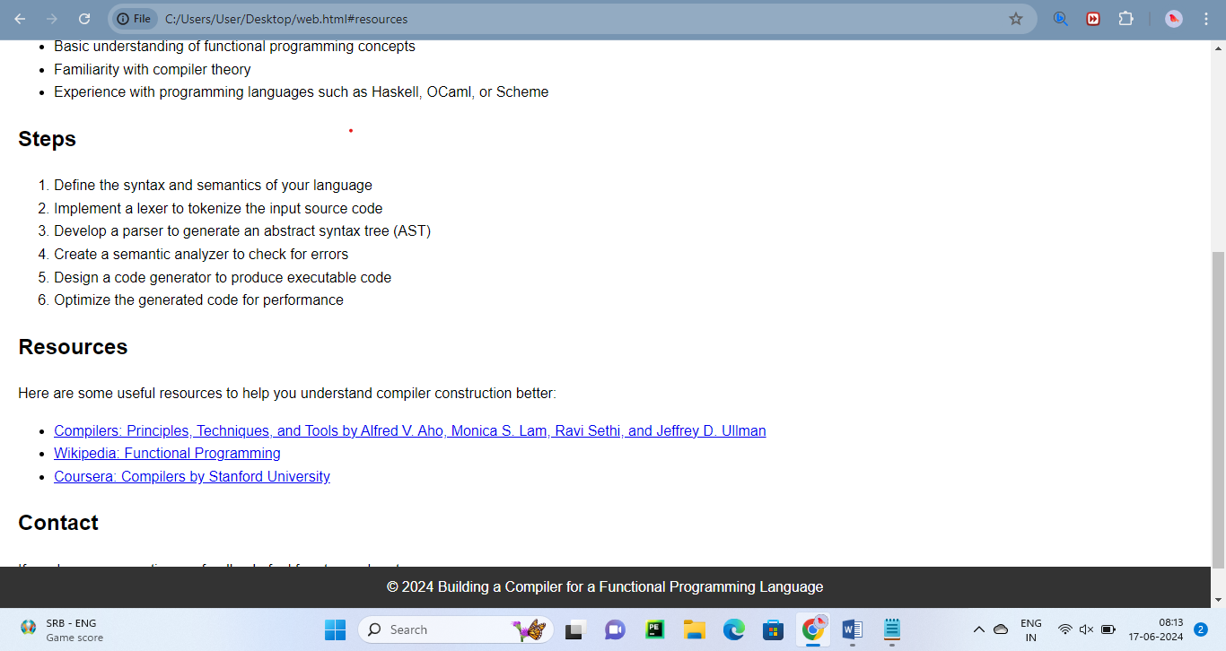

**Conclusion:**

Overall, a well-designed UI for a compiler for a functional programming language streamlines the compilation process, supports collaboration and knowledge sharing, and empowers users with the tools and resources needed to effectively compile and manage code.